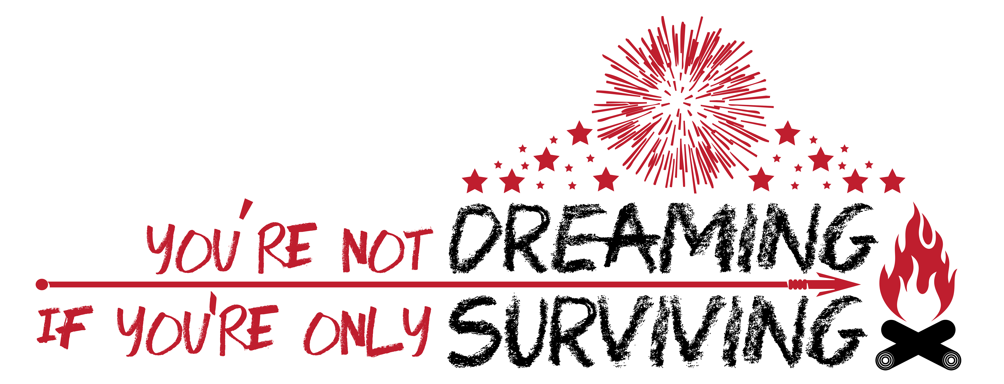

What are Peer Group Sessions?

Small Peer Groups:
Each youth participant at the retreat will be paired with a small peer group. These groups will meet in classrooms throughout the week. These sessions are attended by youth only, with the exception of the staff co-facilitator. Throughout the week, youth will be encouraged to discuss personal goals and experiences as well as engage with their peers through a variety of activities.

Youth Facilitators:
The peer group sessions are facilitated by a young adult retreat participant and a staff retreat participant. All co-facilitators are recruited, screened, and trained by the youth in the Retreat Steering Committee. Facilitators will serve as group leaders and support each session, which follows a curriculum developed by youth on the steering committee.

Youth-Developed Curriculum:
The Retreat Steering Committee youth developed the peer group curriculum. These sessions will focus on this year’s theme, “You’re not dreaming if you’re only surviving.” Youth will be challenged to work together and develop team-building and communication skills, as well as draw inspiration and experience from their peers.

Large Peer Group Sessions:
There will be a large group sessions at the retreat, where all youth and staff will gather together to participate in activities together.

The peer group sessions promise to be an experience filled with learning, sharing, and fun!

